
 PREA methodologies
Creation of a PDEF (DEFinition Product) in PLM

Creation of a PREA (Realized PRoduct) in PLM

###
To create a REAlized Product in PLM
You must clone a Generic PREA from a Library for these Product Nature.
- For a PREA with Product nature "Mecanique", the Generic PREA is available in the "DECOUPAGE PSA" PSA Classification Library.
- For a PREA with Product nature "Calibration", "Data Library", "Dote", "Logiciel masque", "Mecanique Electronique Electrique", "Soft", "Vehicle Application", the Generic PREA is available in the "CATALOGUE INGENIERIE" library.
For PREA available in "LIBRARY REPETITIVE" (POFI and NON POFI), the PDEF is created without a generic.

###Methodology:
• Cloning a Realized Product
- Via Graphical Browser with Generic product

###
Cloning a non-generic PREA is prohibited.

###
Electronic and Electric Domain
For Electronic Items, follow these flowchart:
• All about on the Electronic Items management in PLM
- See: Flowcharts, Methodologies
For Connectors and Peri-Connectors, follow these flowcharts:
PDEF creation is managed by NON POFI Manager, in LIBRARY REPETIVE NON POFI.
• Flowcharts and Methodologies PLM concerning Connectors and Peri-Connectors
For PREA for electrical harness are automatically created in mass with PTA Auto tool.
• In mass creation of NP PA PDEF (PTA Auto)

ID Card attributes of a PREA in PLM (mandatory attributes are in red)
For more information about “Product Nature” and “Product type” attributes, click on the link below:
• Product Nature and Product Type attributes in PLM
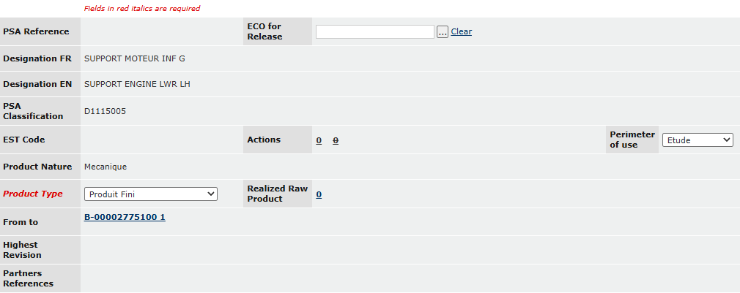

###
Basics Attributes (mandatory attributes are in red)
Owner:
Corresponds to the PREA's ownership.
It is possible to take the ownership of the PREA.
Design context attribute:
This attribute drives the prefix of the PSA reference.
To modify a design context, attribute "PSA Reference" must be empty.
If you wish to modify the Design Context while a PSA reference has been taken (PDEF status at "In Work"), you must recreate a PDEF.
• Cloning a Defined Product
Traceability:
3 levels of Quality Control:
RNF: Reinforced Traceability
STD: Standard Traceability
UNT: Unitary Traceability
Stellantis System Creator:
• Stellantis System Creator Attribute (Stellantis Système créateur)
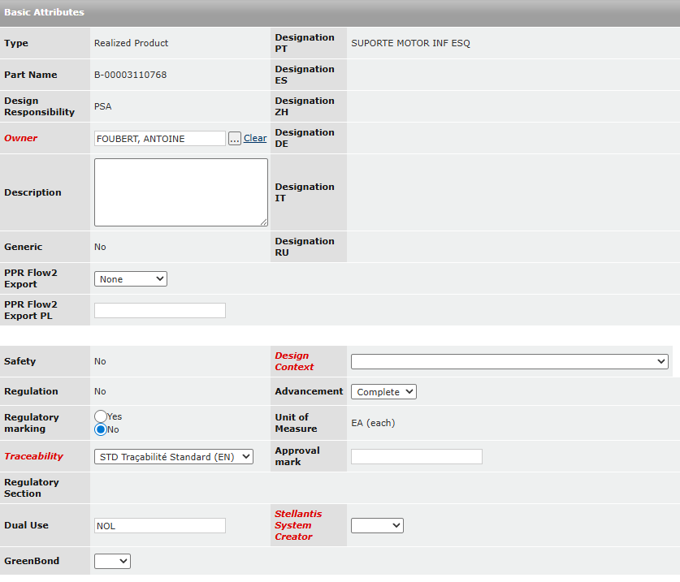

###
Electrical and Electronic features attribute
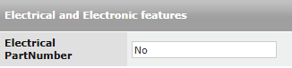

###
Physical Attributes (mandatory attributes are in red)
Realized Mass:
Weight is given by supplier
Gross weight:
Mass of the part including its packaging
Welding reference point:
Part will be welded with welding points if the value is "YES"
Weighted Mass PSA:
YES/NO
If the value is YES, the mass displayed is a real mass weighing in the plant.
• Report weighing part into PLM
- Enter the real mass with the command: "Weighted Mass declaration"
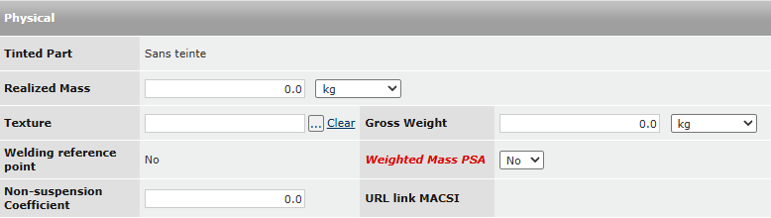

###
Supplier Code Attributes
Add COFOR Intellectual Property, Contracting COFOR, Manufacturer COFOR:
COFOR attributes are mandatory to manage an APQP grid in PLM.
• COFOR Management on APQP grid in PLM
